RETIREMENT - SCHOOL BASED TEACHERS
POLICY & PROCEDURE

CONTENTS

CONTENTS 1
15A.1 INTRODUCTION 3
15A.2 DEFINITIONS 3
15A.3 AGE RETIREMENT 3
15A.3.2 How to apply for Age retirement having reached NPA 4
15A.4 PREMATURE RETIREMENT 4
15A.5 POWERS OF THE GOVERNING BODY 4
15A.6 REDUNDANCY / EFFICIENCY RETIREMENT 5
15A.6.1 Redundancy 5
15A.6.2 Efficient Discharge of the Employer’s Function (Efficiency) 5
15A.6.2.1 Considerations for Efficiency cases 5
15A.6.3 Qualifying criteria for Redundancy/Efficiency related Pension Benefits 6
15A.6.4 Qualifying Criteria for Added Years enhancement 6
15A.6.5 Calculation of discretionary Added Years enhancement 7
15A.6.6 Governing Body considerations when awarding Added Years 8
15A.6.7 Procedure for handling cases related to Efficiency or Redundancy 9
15A.7 ILL-HEALTH RETIREMENT 10
15A.7.1 Criteria for Ill Health retirement 10
15A.7.2 Total Incapacity Benefit (TIB) 10
15A.7.3 Partial Incapacity Benefit (PIB) 10
15A.7.4 Appeals 10
15A.7.4 How to apply for Ill Health Retirement 10
15A.7.5 Criteria for Total Incapacity Benefit Added Years Enhancement 11
15A.7.6 Retirement date 11
15A.7.7 Cost of Enhancement 11
15A.8 ACTUARIALLY ADJUSTED BENEFITS (AAB) VOLUNTARY PREMATURE RETIREMENT 11
15A.8.1 Qualifying Criteria for Accessing AABs 12
15A.8.1.1 Teachers in the TP Scheme before 1 January 2007 12
15.A.8.1.2 Teachers joining the TP Scheme after 1 January 2007 12
15A.8.2 How to apply for Actuarially Adjusted Pension Benefits 12
15A.9 PHASED RETIREMENT 13
15A.10 RESOLUTION OF GRIEVANCES 13
Appendix 15A1 - Flowchart for age retirement (teachers) 15
Appendix 15A2 - Flowchart for efficiency/redundancy retirement (teachers) 17
Appendix 15A3 - Flowchart for ill health retirement (teachers) 18
Appendix 15A4 - Flowchart for actuarially adjusted benefits retirement (teachers) 21

15A | RETIREMENT - TEACHERS

15A.1 INTRODUCTION

This Chapter gives advice on the circumstances in which Teachers may retire and sets out the policy of the Council with effect from 1 April 2007, where the Regulations give Authorities discretion to make compensatory payments.

The national website for members of the Teachers’ Pension Scheme can be found at http://www.teacherspensions.co.uk/ .

15A.2 DEFINITIONS

Retirement: There are three types of retirement – (a) Age Retirement, (b) Premature Retirement and (c) Phased Retirement.

These are defined later in this chapter.

Reckonable Service (Teachers): The number of years and days a teacher has been in the Teachers' Pension Scheme (pro rata for part time staff), plus any other service (s)he may be entitled to count for pension purposes. Reckonable service therefore includes:

- employment during which contributions have been paid to the Teachers' Superannuation Scheme;

- service transferred from another pension scheme or arrangement;

- additional service purchased by the payment of extra contributions and/or a lump sum.

Added Years: These are the number of years' service the Governing Body has discretion to consider as a basis for the award of compensation in cases of premature retirement on the grounds of redundancy or efficiency of the service.

Important Note : The Teachers’ Pension Scheme has discretionary provisions that allow for the award of “Added Years” enhancement to a persons pension benefits. It is at the discretion of the Governing Body to consider any such awards and given the long term financial commitment these enhancements can produce they must exercise due diligence and consider the current and future financial situation of the school.

15A.3 AGE RETIREMENT

The National Conditions of Service for School Teachers (Burgundy Book) states that the normal retirement age for teachers is 65. However, when employees who belong to the Teachers’ Pension Scheme reach the Normal Pension Age (NPA) they may choose to retire and receive immediate pension benefits. The NPA differs, dependent upon when the teacher joined the pension scheme as detailed in 15A.3.1

15A.3.1 Normal Pension Ages

Teachers in scheme before 1 January 2007 | 60 years
Teachers entering scheme from 1 January 2007 | 65 years

15A.3.2 How to apply for Age retirement having reached NPA

In the first instance the teacher should notify the school of their intention to retire so that management can begin to make arrangements for dealing with the implications for the school.
Because the Teachers’ Pension Scheme is not administered by the Council it is advised that any teacher intending to retire as a result of reaching the normal pension age (see 15.3.1) should apply approximately 4 months before the date of their retirement by completing Part A of the Teachers’ Pensions (TP) “ Application for Retirement Benefits - Age” Form “AGE APP”.
Please note - Teachers can get the Form from the, Teachers Pensions Team (TP Team) at teacherspensionsteam@croydon.gov.uk or obtain it from Teachers’ Pensions via their website or telephone 0845 6066166.
Having completed Part A, the teacher should send the form direct to the TP Team, so that they can complete Part B, certify the form with the Local Authority stamp and then forward it to Teachers’ Pensions for processing.
Appendix 15A.1 provides flowcharts showing how to apply for age retirement for those schools that use the Council’s payroll (flowchart 9a) and schools that do not (flowchart 9b).

15A.4 PREMATURE RETIREMENT

Circumstances when premature retirement benefits may be applied for are :-

(a) Redundancy;

(b) The Efficient Discharge of the Employer's Functions;

- Ill-Health.

- Actuarially Adjusted retirement benefits

Each of these is described further on in this Chapter.

15A.5 POWERS OF THE GOVERNING BODY

The governing body of a school with a delegated budget is empowered to agree the premature retirement of a teacher, but in doing so must comply with:-

(a) the provisions of the Teachers' Pension Scheme;

(b) the policy of the Council in respect of all premature retirements of teachers and, where discretionary added years compensation is being considered, the governing body is prepared to have the costs deducted from the school’s delegated budget.

The school’s HR provider is available to assist schools in progressing cases of premature retirement and it is recommended that they be involved from an early stage.

15A.6 REDUNDANCY / EFFICIENCY RETIREMENT

15A.6.1 Redundancy

The circumstances under which redundancy will arise and how to estimate the one-off redundancy payments are set out in the Staffing Reductions chapter and its appendices, along with guidance on the handling of individual cases.

In addition to a one-off redundancy payment an employee whose post is made redundant may also be eligible for a retirement lump sum and an annual pension. (See 15A.6.3 below)

15A.6.2 Efficient Discharge of the Employer’s Function (Efficiency)

Employees who meet the criteria detailed below may be retired prematurely in the interests of the efficiency of the service. The policy of the Council allows for premature retirement of eligible employees to take place in the following circumstances:-

(a) To assist staff with problems of ill-health when an application for retirement on health grounds has been considered and refused. The advice of the Council's Medical Adviser must be sought before a decision is made under these criteria.

(b) To enable a change to be made in the organisation of the school which does not give rise to redundancy.

(c) To resolve problems with employees who are unable to meet the changing requirements of their role. This would not normally be applied when a member of staff is already the subject of action under the Unsatisfactory Performance or Disciplinary procedures.

(d) In such other circumstances as may be agreed from time to time by the governing body in consultation with the recognised teachers' professional associations or trade unions and with the approval of the Council.

All cases of premature retirement on Efficiency grounds must be coupled with cost savings or any other clearly identifiable benefits to the school.

The application form for Premature Retirement Benefits is only available on request from Teachers’ Pensions and is not available from their website.

15A.6.2.1 Considerations for Efficiency cases

In deciding on such cases, the following considerations must be addressed:-

(a) The suitability of the individual for re-training where appropriate to make a continuing contribution to the work of the school.

(b) Whether the academic and financial objectives of the school can be achieved more appropriately in respect of any individual by means other than premature retirement.

(c) How the employee's retirement would affect the structure and promotion prospects of staff at the school.

(d) The prospects for finding an adequate replacement.

(e) If a post is to be abolished whether there are any alternatives to premature retirement for the individual concerned and whether any of them would be preferable.

Please note: There is no entitlement to a one-off redundancy payment where premature retirement is on the grounds of efficient discharge of the employer’s functions.

15A.6.3 Qualifying criteria for Redundancy/Efficiency related Pension Benefits

Retirement benefits (a retirement lump sum and an annual pension) may be paid to an employee if (s)he meet the following criteria:

- is aged 55 years or over on the date the redundancy takes effect; and

- has two years' pensionable employment at any time after 5 April 1988; or
- has two years' pensionable employment at any time, if individual was in pensionable employment on 6 April 1988; or

- has five years’ pensionable employment at any time; and

- applies for premature retirement.

Qualifying Criteria for Added Years enhancement

An employee who meets the criteria for premature retirement (as detailed previously) must satisfy the following criteria in order for the governing body to consider awarding discretionary added years enhancement:

(a) (s)he must be aged 55 years or over on date retirement takes effect; and

(b) have at least ten years' eligible service; and

(c) apply for premature retirement.

In addition, the award of discretionary Added Years for efficiency cases should only apply in the following circumstances:

  - To allow a replacement at the beginning of a school year of a teacher who reaches retirement age during the school year.

  - Ill-health problems when an application for retirement on health grounds has been considered and refused, subject to the advice of the Council's Medical Adviser.

  - Major changes to staffing structure leading to a reduction in the senior management structure or the replacement of a teacher at a substantially lower salary.

  - Replacement of teacher on protected salary by a teacher receiving a significantly lower salary.

Added years’ enhancement is not an entitlement but is a discretionary decision of the Governing Body. The decision of the Governing Body is final.

15A.6.5 Calculation of discretionary Added Years enhancement

If the teacher satisfies the aforementioned criteria then, in cases of premature retirement on the grounds of Redundancy or Efficiency, an added years pension and lump sum may be granted by the Governing Body, based on a notional credited period of service which may not exceed the shortest of the following periods:

- a period equivalent in length to the aggregate of his/her service;

- a period which when added to his/her service does not exceed in aggregate 40 years. (This period may be restricted further in the case of staff who have been granted compensation for the loss of an earlier employment);

- a period up to the age of 65;

- a period related to service in accordance with Table A of this Chapter;

Please note - The School should fully consider the ongoing financial commitment resulting from the award of any added years benefits before any offer is made to an individual.

Table A

Service (Years) | Credited Period of Service may be granted up to (Years)
Over 20  18 - 19  16 - 17  14 - 15  12 - 13  10 - 11  8 - 9  5 - 7 | 6⅔  6  5⅓  4⅔  4  3⅓  2⅔  2

15A.6.6 Governing Body considerations when awarding Added Years

The School should fully recognise the ongoing financial commitment resulting from the award of any added years benefits before any offer is made to an individual, taking into consideration the following:

- The criteria for premature retirement on these grounds must be satisfied and the approval of the Local Authority obtained before any commitment is made to the member of staff.

- Added Years are awarded pro-rata for part-time employees.

- In the case of a person who, at the time of ceasing his/her employment, has an entitlement to an occupational pension in respect of an earlier period of employment, some reduction may be necessary to the rate of the annual compensation.

- These are the maximum Added Years credits in accordance with the Teachers’ Pension Scheme and therefore a lesser amount could be awarded, dependant upon the circumstances.

- Benefits for Added Years are calculated in the same way as the normal/notional retirement benefits.

- A governing body could award a service credit in excess of the appropriate levels shown in Table A of this Chapter, to a teacher, but only provided it does not exceed the maximum shown in the table and it can meet the additional costs from within the school’s delegated budget.

Head Teachers/Governors can ask their HR provider to arrange for estimates of redundancy, pension and compensation payments to be calculated.

15A.6.7 Procedure for handling cases related to Efficiency or Redundancy

Cases of possible premature retirement on the grounds of efficiency/redundancy can arise in one of two ways.

(a) The head teacher and/or governing body may take the initiative in considering one or more employees for retirement, on grounds of efficient discharge of the employer’s functions / redundancy, or

(b) The employee may submit an application to be considered for early retirement, either on his/her own initiative or as a result of an invitation for applications to be received.

The employee should be advised to consult his/her teachers' professional association or trade union whenever premature retirement is being contemplated.

The governing body or head teacher should seek advice from their HR Provider on whether:

(a) the case would meet the criteria for premature retirement; and/or

(b) the circumstances are likely to meet the exceptional criteria for Added Years.

Where it is likely that the case could proceed, an estimate of the pension lump sum and annual pension should be obtained from the HR provider. The employee should again be advised to consult his/her teachers' professional association or trade union.

The matter should then be discussed with the employee to obtain his/her agreement to proceed with the application for premature retirement. Where it is agreed that the application will proceed, the head teacher should refer the case, with appropriate background information, to the governing body for approval to the retirement and to the financial terms relating to it, subject to the Executive Director of People (formerly Children, Families and Learners) agreement as appropriate.

Appendix 15A.2 provides flowcharts showing how to apply for premature retirement on the grounds of efficiency or redundancy for those schools that use the Council’s payroll (flowchart 9g) and schools that do not (flowchart 9h).

The Executive Director – People (formerly Children Families and Learning) should be notified in writing of the grounds on which the governing body intends to grant the early retirement and his agreement sought to the decision being implemented.

If the governing body decides to proceed with a premature retirement or apply terms which do not comply with the policy of the Council, the Executive Director of People (formerly Children, Families and Learning) will advise the governing body that its decision does not comply with Council policy and any costs arising will not be met from central funds. This advice will be confirmed in writing to the governing body. The decision of the Executive Director is final.

The last day of service should be agreed between the Governing Body and the employee and HR Provider notified in writing. The HR Provider, on behalf of the Executive Director of People, will then confirm the arrangements in writing to the employee and TP and take the necessary action for the pension benefits to be paid.

15A.7 ILL-HEALTH RETIREMENT

Guidelines for handling individual cases of ill-health are set out in Chapter 9. The arrangements for the granting of ill-health pensions to teachers are described below.

15A.7.1 Criteria for Ill Health retirement

The decision as to whether or not the ill-health retirement is granted to a teacher is based on medical evidence and will be made by Teachers' Pensions and not the school's governing body or the Council.

While the requirement for permanent incapacity from teaching remains, the severity of the medical condition and its impact on the future earnings capacity of the teacher will determine the scheme member’s level of benefit when retiring on the grounds of ill health.

15A.7.2 Total Incapacity Benefit (TIB)

This will be granted to those members who would only be capable of work that would be greatly below the overall job weight of a teacher.
TIB will include a half prospective service enhancement to normal pension age.

    - Partial Incapacity Benefit (PIB)

This will be granted to those permanently incapable of teaching, but capable of a range of other types of work.
Under PIB there is no service enhancement, but the member would not be subject to the reduction normally applied to benefits because of early payment. Also the benefit will not be reviewed if the member becomes employed in any capacity outside teaching.

    - Appeals

The existing Teachers’ Pensions appeals system has been extended to cover those appealing against the award of the lower level of benefit as well as those appealing against a rejection of their application for ill-health retirement.

15A.7.4 How to apply for Ill Health Retirement

Teachers who may be contemplating giving up teaching because of problems of ill-health may apply to the Teachers' Pensions for infirmity benefits.

Teachers considering ill-health retirement should obtain forms “ILL HEALTH APP” and “ILL HEALTH MED” (from either Teacher’s Pensions or the TP Team) which include full instructions about making the application and the arrangements for the statutory medical examination. Further advice and information can also be obtained from the school’s HR provider.

Appendix 15A.3 provides flowcharts showing how to apply for ill-health retirement for schools that use the Council’s payroll (flowchart 9k) and schools that do not (flowchart 9l).

15A.7.5 Criteria for Total Incapacity Benefit Added Years Enhancement

The Added Years enhancement for pension and lump sum is set out in Table B shown below.

Table B

Reckonable Service | Added Years
Under 2 years  2 years up to 9 years 364 days  10 years up to 13 years 122 days  More than 13 years 122 days | None  Double the actual reckonable service, (but not more than if they taught until they were 65).  20 years, (but not more than if they taught until they were 65).  Whichever is greater of 20 years (this cannot be more than if they had taught until they were 65):  or  the actual reckonable service plus 6 years 243 days (this cannot be more than if they taught until they were 60).

Teachers who do not qualify for infirmity benefits may be eligible for a short-service grant. This grant is a lump sum payment calculated at the rate of 1/12 of the average salary for each year of pensionable service, odd days counting as 1/365 of the rate for a year.

15A.7.6 Retirement date

A successful application for ill-health retirement benefits means that the teacher is permanently unfit for teaching and retirement must take place at the earliest possible date. The employer is not under any contractual obligation to serve notice to terminate the teacher’s contract.

15A.7.7 Cost of Enhancement

The cost of service enhancements in cases of ill-health are charged to the relevant pension fund and not to either the Council's General Fund or the school's budget

  - ACTUARIALLY ADJUSTED BENEFITS (AAB) VOLUNTARY PREMATURE RETIREMENT
These benefits will be actuarially reduced permanently, according to the teacher’s age at retirement (although the reduced pension will attract index linking), therefore a teacher should think about obtaining independent financial advice when considering whether to take this form of retirement.

15A.8.1 Qualifying Criteria for Accessing AABs

15A.8.1.1 Teachers in the TP Scheme before 1 January 2007
A teacher may voluntarily access their retirement benefits before the Scheme’s normal retirement age of 60 if they are aged 55 or over and have some pensionable or excluded employment on or after 30 March 2000 and leave employment.
If a teacher is aged between 55 and NPA and has been in pensionable employment on or after 30 March 2000, they may be able to obtain early access to their pension benefits, which will be actuarially reduced.

15.A.8.1.2 Teachers joining the TP Scheme after 1 January 2007

A teacher may voluntarily access their retirement benefits before the Scheme’s normal retirement age of 65 if they are aged 55 or over and have some pensionable or excluded employment on or after 30 March 2000 and leave employment.
If a teacher is aged between 55 and NPA and has been in pensionable employment on or after 30 March 2000, they may be able to obtain early access to their pension benefits, which will be actuarially reduced.

15A.8.2 How to apply for Actuarially Adjusted Pension Benefits

In the first instance the teacher should notify the school of their intention to retire so that management can begin to make arrangements for dealing with the implications for the school.
Because the Teachers’ Pension Scheme is not administered by the Council it is advised that any teacher intending to retire should apply approximately 4 months before the date of their retirement by completing Part A of the Teachers’ Pensions Application for Actuarially Reduced Benefits form “ARB APP”.
Teachers can get the Form ARB APP from the TP Team or from Teachers’ Pensions via their website or telephone 0845 6066166.
Having completed Part A, the teacher should send the whole application form direct to the TP Team, so that they can complete Part B, certify the form with the Local Authority stamp and then forward it to Teachers’ Pensions for processing.
Please note: If a teacher is in pensionable employment when they apply for actuarially adjusted benefits they must obtain the consent of their employer to gain immediate access to retirement benefits. Employers cannot withhold their consent for longer than 6 months from the date on which the teacher submits their request.

Teachers in excluded employment (E.g. teaching employment which would have been pensionable but for an election to opt-out of the scheme or the absence of a part-time election) are not permitted to take AAB whilst they remain in "excluded" employment prior to Normal Pension Age (NPA).

Subject to the employer's consent, actuarially adjusted pension benefits are paid from the day after the last day of pensionable or excluded employment.

If a teacher retires on AAB, with the possibility of re-employment at the same school, there must be a "cessation of employment" which is a break in contractual employment before pension benefits can be paid, so in such a case, further advice should be sought from Teachers Pensions or the TP Team.

Appendix 15A.4 provides flowcharts showing how to apply for actuarially adjusted benefits for schools that use the Council’s payroll (flowchart 9e) and schools that do not (flowchart 9f).

15A.9 PHASED RETIREMENT
This option is available to teachers who have attained the age of 55 years where they can take part of their pension and continue to work. Teachers may take phased retirement without having a break in employment, up to a maximum of 75% of total benefits, provided that their pensionable salary reduces by at least 20% for a minimum of 12 months. This could be because they have taken up a post of lesser responsibility or are working fewer hours.
Teachers can get the ‘Application for Retirement Benefits: phased’ from the TP Team or from Teachers’ Pensions via their website or telephone 0845 6066166.
The application for phased retirement must be made within three months of starting employment in a reduced capacity and teachers must agree the arrangement with their employer, who will be required to provide confirmation of the salary reduction on the application form.
Phased retirement can be applied for twice before final retirement.

15A.10 RESOLUTION OF GRIEVANCES

Any grievance or dispute between an employee and the governing body or the Council in the use of provisions for early retirement shall be dealt with in accordance with the school's grievance procedure.

Ill health retirement of teachers under the Teachers' Superannuation Scheme is not a subject of any grievance or dispute between the employee and the governing body or the LA. The scheme has its own appeal arrangements for cases which are not approved by the Teachers' Pensions.

Appendix 15A1 - Flowcharts for age retirement (teachers)

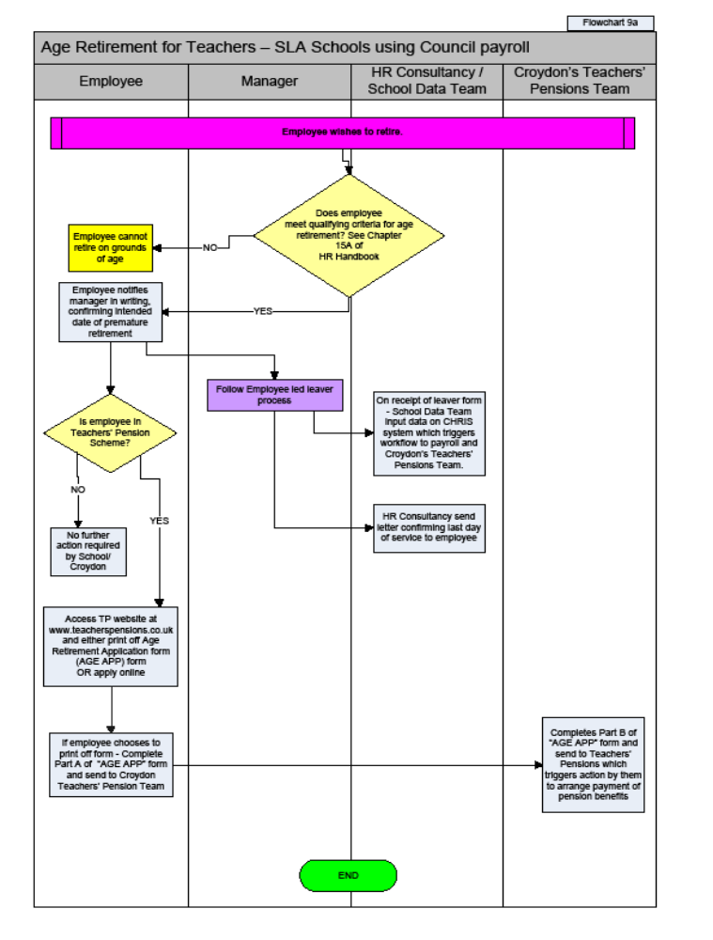
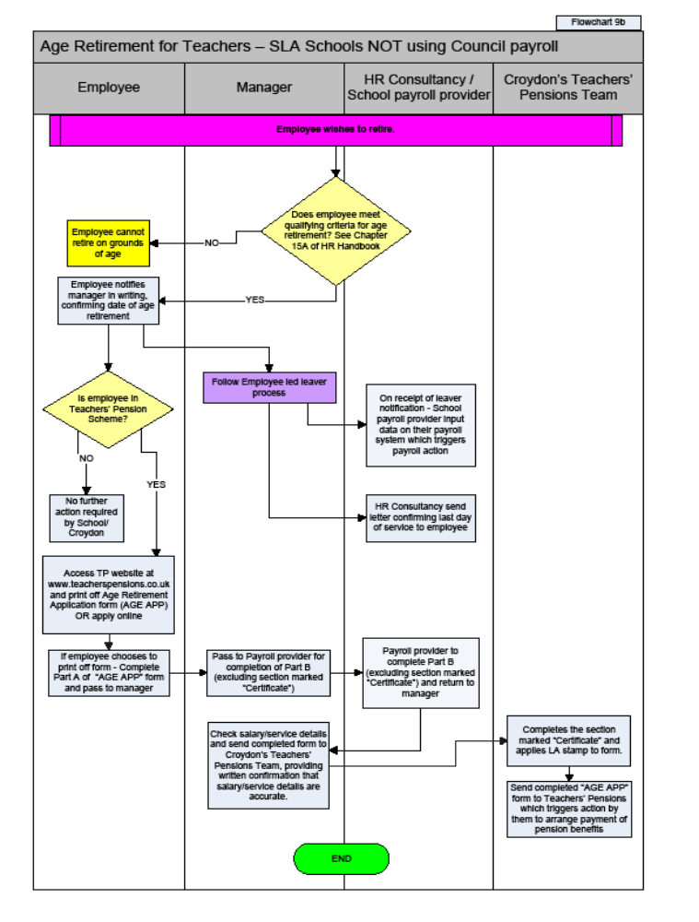

Appendix 15A2 - Flowcharts for efficiency/redundancy retirement (teachers)

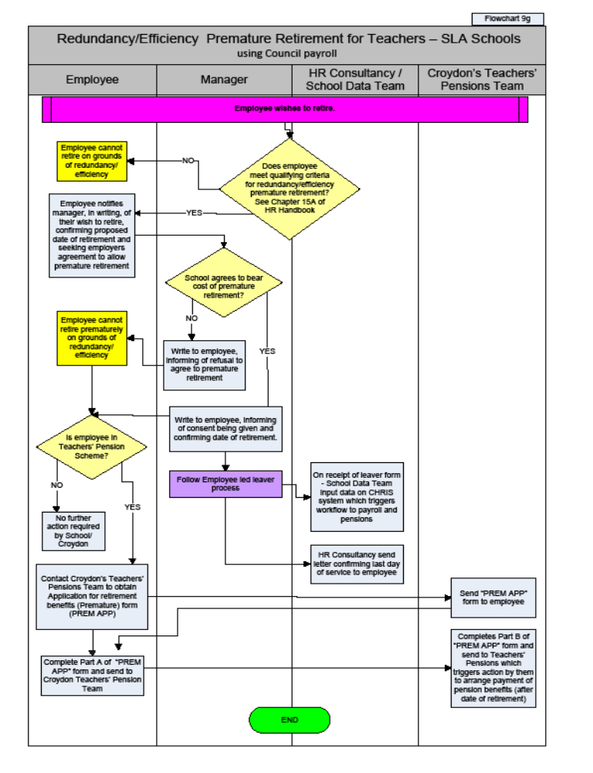

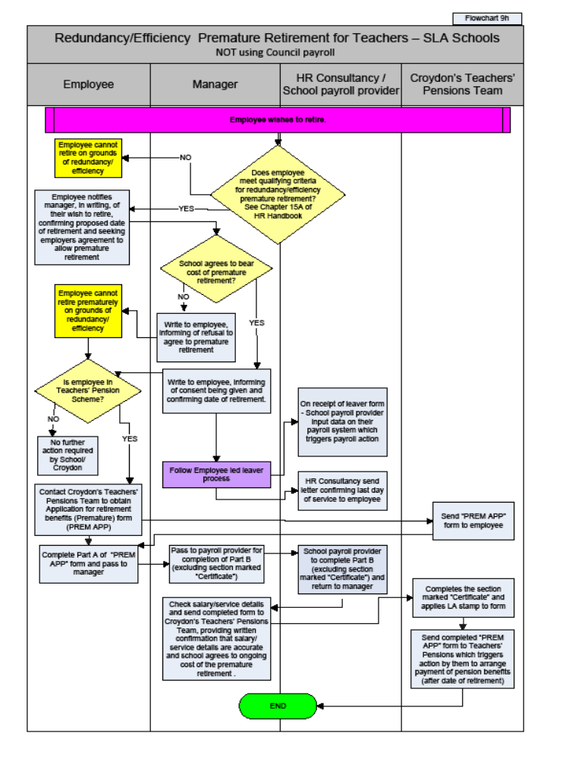

Appendix 15A3 - Flowcharts for ill health retirement (teachers)

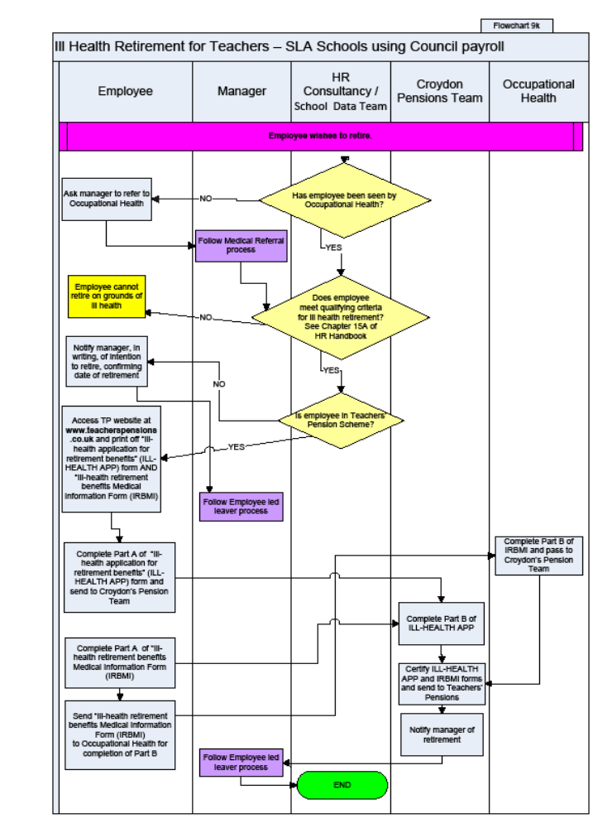
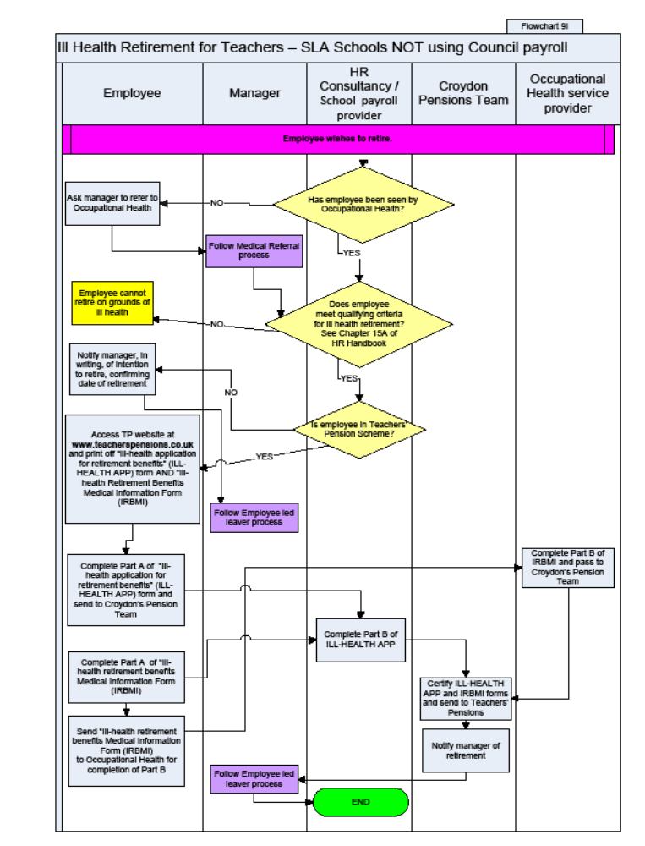

Appendix 15A4 - Flowcharts for actuarially adjusted benefits retirement (teachers)



