Welcome to the New Occupational Health Service

Online Management Referral
Guidance Notes – for Schools

The Occupational Health Service online Management referral process goes live from 16 April 2012. From this date you will only be able to submit your OH referral form online. Here you will find all you need to know to enable you to understand and follow the process.

Below you will find guides in 2 formats.

The first is a very simplified version, (Quick overview) giving a quick and easy insight for you to understand the concept.

The second is the step by step version helping you through the process.
Please ensure you read it through before you attempt your first online referral request.

You will also find this guide on the schools website

For details of who to contact for help – see end of guidance notes

Online Management Referral Process – Quick Overview

HR / Manager / Originator
Creates their own User Profile and completes the Management Referral Online


To create a new user profile navigate to the admin URL
https://ccc.tempus.co.uk/cohortmanref/newuser.aspx
1) Complete set up
2) Log on screen appears – Log on
3) Complete OH Referral
NB you only need to use the Logon URL address, to log on to system thereafter https://ccc.tempus.co.uk/cohortmanref/

Response sent back to the Manager / Originator & Updates on Dashboard View

Occupational Health
Receives the Referral into Cohort and processes the Consultation



Online Management Referral Application Process

This section details the functionality of the online application’s interface and will cover:
- Creating a New Manager User Profile
Completing the Referral Application

A user account should only be created by mangers. Managers are defined as those that manage the employee’s PDCS.

Creating a Manger User Profile

To create a new user profile navigate to the admin URL , new user log on.

https://ccc.tempus.co.uk/cohortmanref/newuser.aspx

This will load the Cohort Online Management Referral Registration screen.

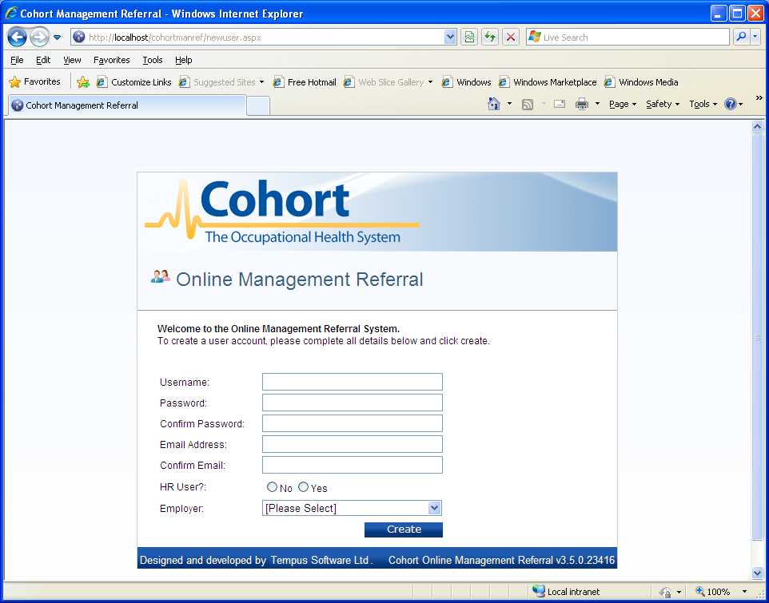

Enter the following information:

- Username – This should be recognizable by the COHORT System Administrators within the OHS service. e.g. your name.
- Choose a Password
- Confirm your Password
- E Mail Address – This MUST be your Croydon Council email address
- Confirmation of E Mail Address

- HR User – Here the referring manager should select the ‘No’ option. Only HR personnel (within WCR) should select the ‘yes’ option.
N.B Managers will be able to include an HR representative whilst completing the online referral form. This will give them a restrictive view of the referral via the dashboard screen.

- Employer – It is essential that the correct Employer / Contract is chosen, as this will affect what Questionnaire you will complete and the response form you receive!

Click Create which will register you within the system as a user.

N.B Only System Administrators in OH will have access to this User in the Admin section of Cohort.

Once you have created a User profile, you will automatically be presented with the log-in screen.

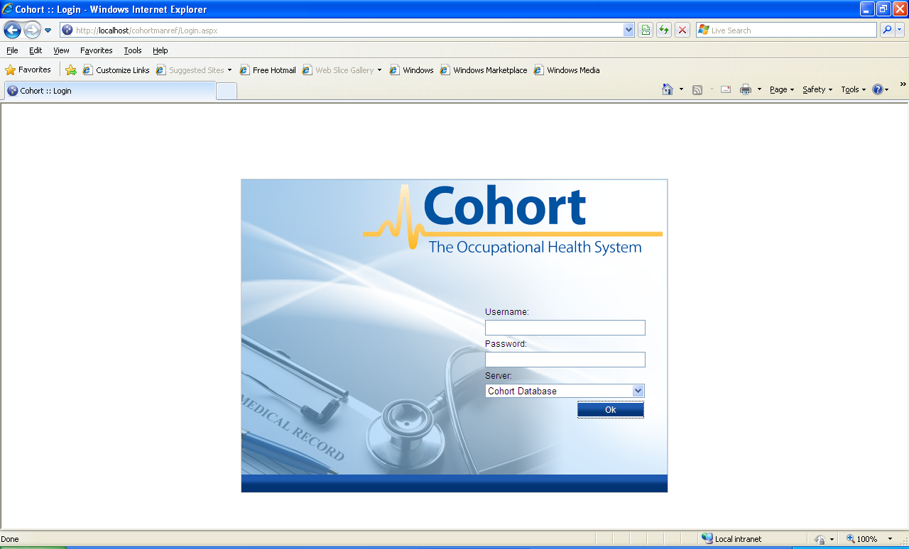

You will need to log in with the ‘Username’ and ‘Password’ which you have just created.

To log on throughout the referral process, and to have access to the outcome, Managers will need to get back to this log in page.

To get to the log in page, navigate to the admin URL

https://ccc.tempus.co.uk/cohortmanref/

Username & login

At present there is no reminder facility for forgotten passwords. It is therefore important that you choose a memorable username and password.

To help you, here are some examples of choosing a Username & password that is memorable

For your username – your employee number or Surname

For your password - Focus on the things you like. Choose a favorite number (or two), a favorite word/thing (or two), a favorite symbol (or two). Choose an order and put them all together into one long string, containing one capital letter, one number and be min 8 and max 18 characters long. Ensure you make a note of your username and password

Online Management Referral Dashboard View

Upon successful logon, the Online Management Referral Dashboard will be loaded.

This first page provides the functionality to:

- review any ongoing or existing online management referrals (subject to housekeeping);
- search the database;
- create a new management referral.

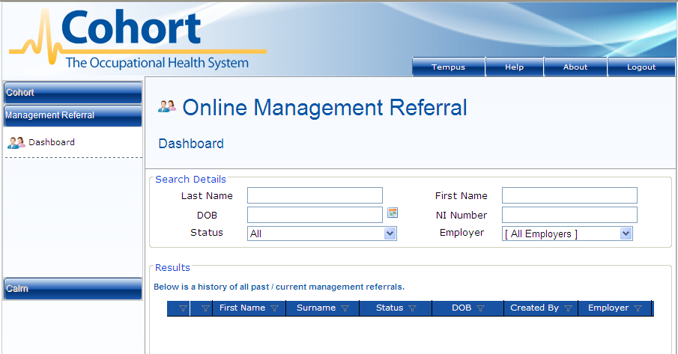
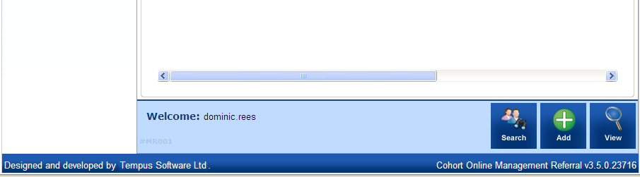

The Dashboard view provides the following, at-a-glance, information, each of which is capable of being used as a filter by selecting the filter function:



- Priority (Green is normal priority; Red is high priority)
- First Name
- Surname
- Status – the status values are:

(1) UNSAVED (6) SAVED TO COHORT – ALLOCATED
(2) SAVED NOT SENT (7) CLOSED BY ADMINISTRATOR
(3) SENT TO OCCUPATIONAL HEALTH (8) CLOSED AND RETURNED TO
(4) MATCHED TO PATIENT ORIGINATOR WITH DECISION
(5) SAVED TO COHORT – NO ALLOCATION (9) RECORD CLOSED

- Date of Birth (DOB)
- Created by (logon of the referral’s originator)
- Employer
- Nation Insurance Number (NI) –this information is not required
- Created on (date)?

- Completed (date)?

Clicking on the View button will load the specific record for review or completion once you have selected the correct record by placing a tick in the checkbox

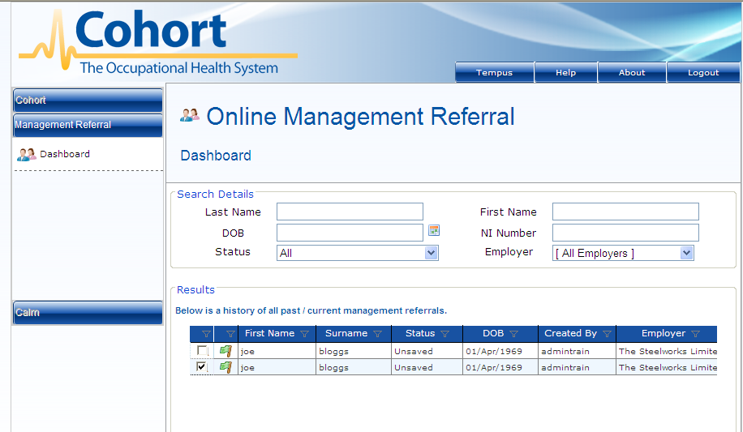



Clicking on the Home button contained in the left-hand menu will return the application to the dashboard view.
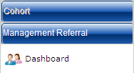

Online Management Referral Search Function

The Online Management Referral application allows a user to search for both current online management referral work items and (subject to the application’s setup) to also search the integrated Cohort database, as restricted by employer, for existing patient / registration / employee records. However the second option is currently unavailable.

To undertake a search, first enter the appropriate search criteria. You can select from any of the following:

Last Name First Name
DOB NI number
Status Employer

Click on the Search button. 

Search results are displayed, initially, as shown, which in this instance has returned a patient/registration/employee.

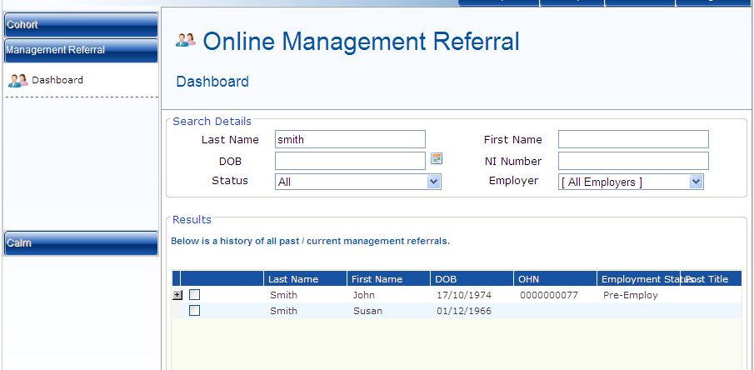

This Search facility allows you to search for a client, to which you want to create a referral for,

If the client has already had a referral, you will see the ‘+’ icon alongside. (However this will only be likely once you have already processed several referrals via the online system.)

Clicking on the + symbol will expand the returned patient/registration/employee record to show any associated online management referrals.


The expanded view’s grid also contains the following additional information:

- Last Modified By (username)
- Last Modified On (date)
- Created By (name)
- Completed (date)
- Referrer Originator (username of the originator)
- Manager’s Name (manual entry)
- Status
- Reason (drop-down-menu value relating to the reason for the referral

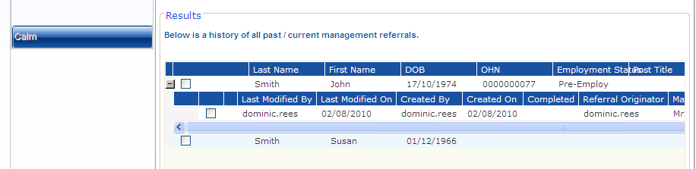

To select a record to view, click the checkbox and then click on the View button

Creating a New Online Management Referral

To create a new online management referral for review by Occupational Health, first select the applicable patient/registration/employee record and then click on the Add New button

N.B This will depend on the Admin System Set-up being carried out with the correct association of the Employee etc, and the ability to search the database. (This facility is not currently set up; you will therefore need to manually add in the required criteria)

If you have it set to Add in a client if not in the database, you must add in all the Mandatory criteria first before you can Add.

If the client record is returned/found, simply select the client’s record by placing a tick in the checkbox. If there is a current referral for the client, and a ‘New’ one needs to be created, select the checkbox on the clients’ return, before it is expanded!!



This will load the custom built online management referral questionnaire.

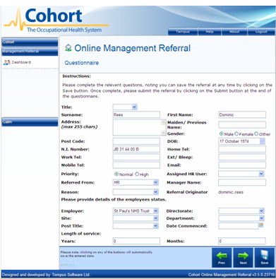

N.B Clicking on the Save button at any point will save the questionnaire for later completion.



N.B. You may complete the whole questionnaire at the same time; however there are mandatory fields on each page that must be completed before you can save the questionnaire.

To navigate between multiple pages, click on the Previous or Next buttons.



You will be able to complete all of the pages within the questionnaire.

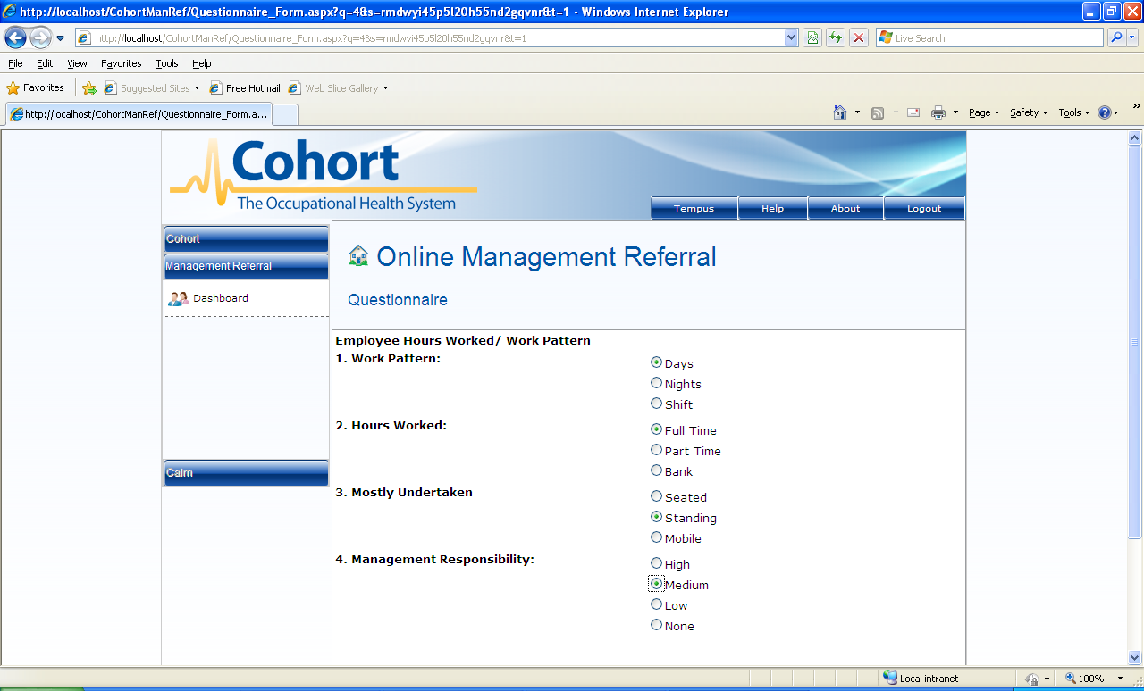
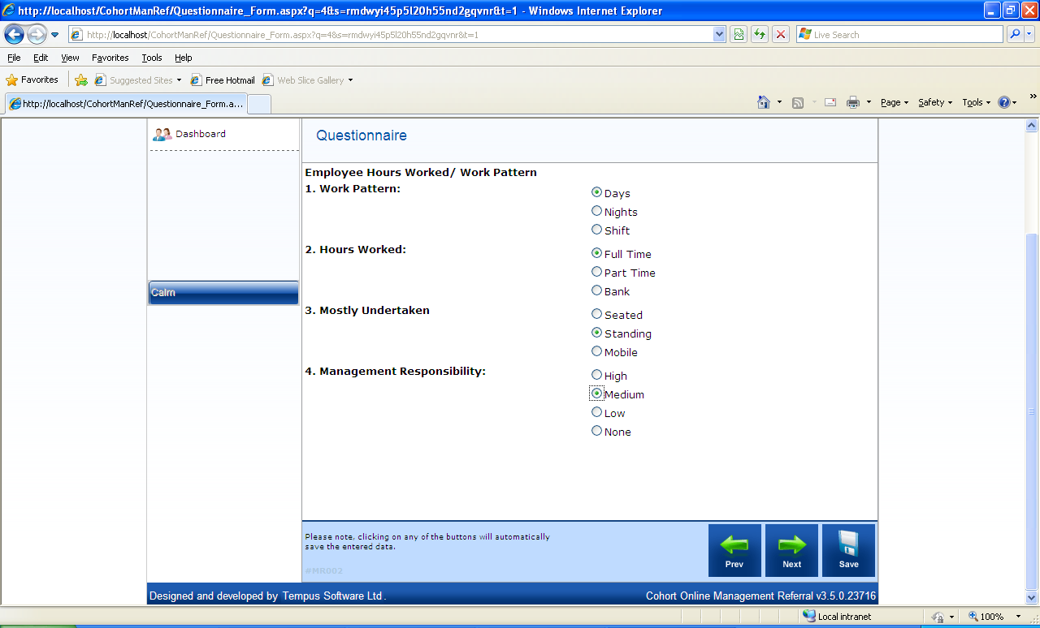

Once all the questions have been completed it will now be possible to send the questionnaire to Occupational Health (and Cohort).

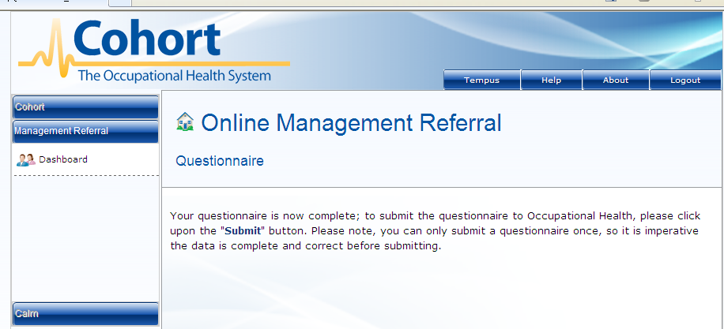
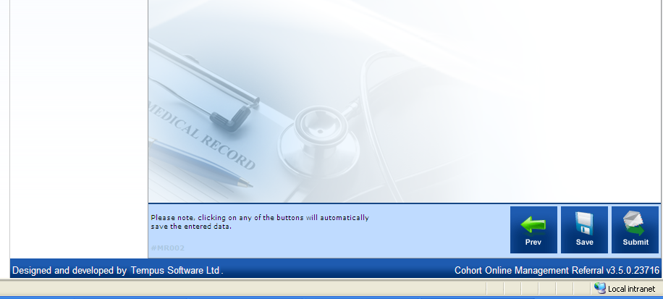

To submit the completed questionnaire, click on the Submit button.



HR User Functionality

It is possible to create a Management Referral User with access to only the dashboard information. This type of user will not be able to view or create any management referral items.

To create a HR User check the HR User checkbox when setting up the user details within Cohort. This will then assign the designated user as a HR User only.

N.B When the user is creating a log in for themselves, this is also an option!

A HR Users view is also restricted by the associated employer link allocated.

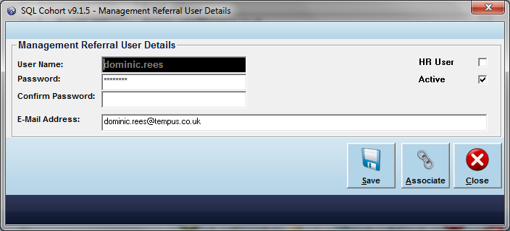

As a given employer may require more than one HR User account setting up, the online user will be required to manually select the appropriate HR User from an employer filtered menu.

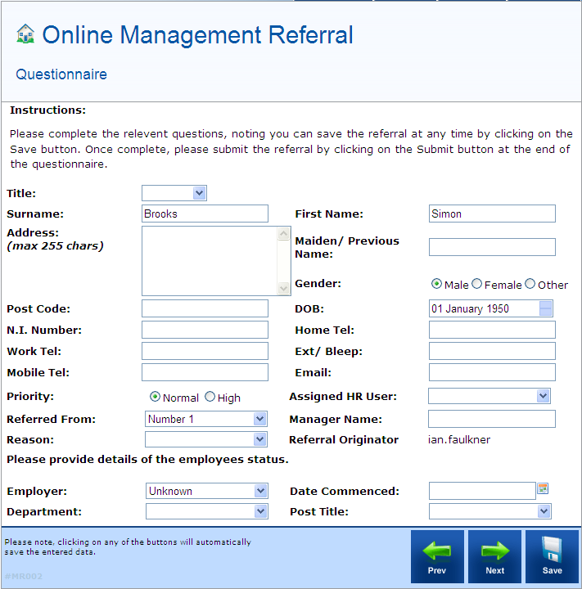
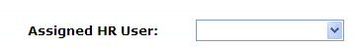

Selecting the appropriate HR User from the Assigned HR User drop down menu will assign the Questionnaire to that specific HR User for overview.

Viewing an Online Management Referral

To view an existing online management referral, select the appropriate record and placing a tick in the checkbox, and clicking on the View button.

This will then load the view page in one of three states, subject to the status of the record selected:

- Partially saved original referral awaiting completion
- Original referral completed – awaiting response view
- Original referral and completed response View

Partially Completed – Before submitting (Up Dating the Referral)

This view will load the partially saved online management referral for completion, and this will be shown in the Status filter column:

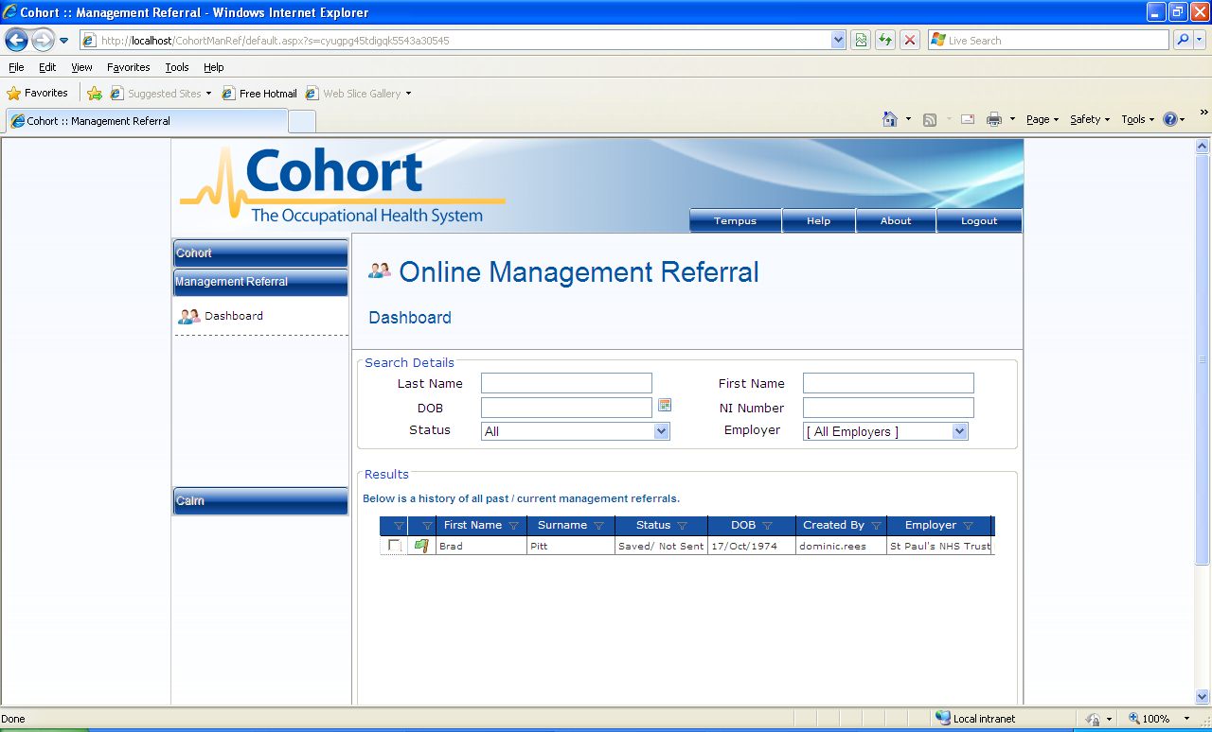

By placing a tick in the checkbox, and select View, the partially saved document will be displayed on the screen, allowing the user to complete the missing data.

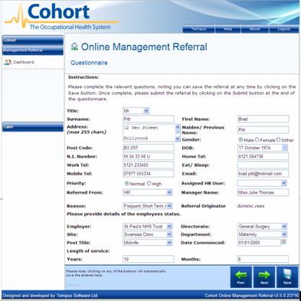

Use the ‘Next’ and ‘Prev’ buttons to navigate to the remaining document

Original Referral Completed View – Awaiting Response

Following submission of a fully completed online management referral by the referral manager/originator, clicking the View button will load the Questionnaire page:

The Questionnaire page is broken down into two sections:

- Original Referral
- Response, which, in this instance, details that no response has been made.

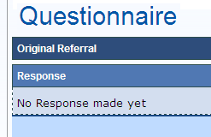

To view the original referral information submitted to Occupation Health, click on the Original Referral tab.



This will load a read-only view of the original questionnaire

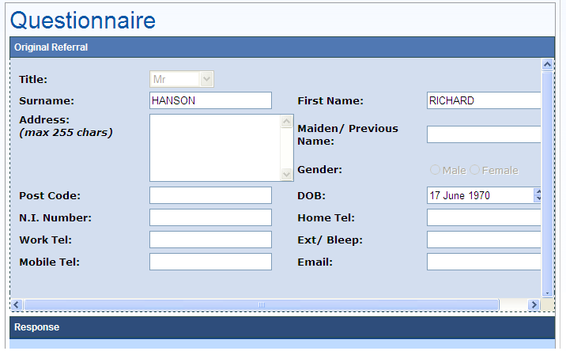

Original Referral and Completed Response View

When an OH response has been sent, the originating Manager will be sent an email alerting them that the response is waiting and to log on to view .

Once the online management referral has been returned by Occupational Health, clicking the View button will load the Questionnaire page but it will automatically display the completed response form

Help is here…………

Please first review the frequently asked questions; if the answer you seek is not there you should contact one of the following as specified:

Contact HR

Email: HR.Advice@croydon.gov.uk
HR advice line: ext 88333

For general queries i.e. Basic requirements for completing a referral,
Log on web address - Online management referral,

Contact Occupational Health

Email: OHReferrals@croydon.gov.uk ,
Telephone: ext 62138

For Password resets
Log on web address - Online management referral
Medical Queries

Online OH Referral
Surgery –Drop in

See surgery dates advertised, just turn up, no appointment necessary

Frequently Asked Questions FAQs

Q. I do not have access to the intranet, how do I access the Website to create an account and log on.

A. You will need to contact one of the help lines, who will provide you with the URL addresses.

Q I have forgotten my password, what do I do?

A. Unfortunately the ‘forgotten password’ facility is still being developed by our systems administrator and therefore does not yet work. It is therefore very important that you make a note of your username and password and keep it somewhere safe for future use.
The Occupational Health team can reset forgotten passwords in extreme cases.

Q What Does ‘HR User’ mean?

A. HR User means that you have the option of including a HR representative to be involved with your particular referral, you can opt for a HR user by choosing this section. The HR user selected will be able to log in and view the referral only.

Q. I need to amend some of the details I recorded on a previous page of my online referral; however it will not allow me to go back to the previous page. What should I do?

A. If you are unable to go back to the previous page to amend it, you should continue to complete the page you are on. Once you have completed this page, save the document, (do not submit) then go back to view your dashboard. This will show your partially completed referral. Click to view and this will take you to the first page.

