Disclosure and Barring Policy 2013
CONTENTS

Summary 1
1 DBS checks and when to use them 2
2 Validity of DBS disclosure certificates 4
3 Portability of DBS disclosure certificates 4
4 DBS checks for those moving jobs within the Council 4
5 Frequency of DBS checking 5
6 Criminal Record Information: Self-disclosures 5
7 Commencement of work prior to receipt of DBS disclosure certificate 5
8 Receipt of a DBS disclosure certificate 6
9 Positive DBS disclosure certificates 7
10 Recruiting from overseas 8
11 DBS checks for agency, partnership workers, contractors, sub-contractors and volunteers 8
12 Volunteers 8
Appendix A: DBS Assessment 10
Appendix B: Deciding Which Posts Need a Disclosure 11
Appendix C: Flowchart to Assess Regulated Activity For Children 15
Appendix D: Flowchart to Asses Regulated Activity For Adults 16
Appendix E: Safe Handling and Storage of Disclosure Information 17
Appendix F: Rehabilitation of and Employment of Ex Offenders 18
Appendix G: Definitions and Additional Information 21
Appendix H: Risk Assessment 24

Summary

Criminal record and barred list information play a crucial part in: safeguarding vulnerable groups, including children; protecting the welfare of all those accessing our services; managing risk; protecting the reputation of the Council; and ensuring appropriate levels of trust and confidence in those delivering Council services. This policy sets out how this infomation is used in the workplace and relates to employees, partnership workers, volunteers, agency staff, contractors and sub-contractors. In other words, anyone working for or on behalf of the Council (including those who work in schools).

Note: Following changes made under the Protection of Freedom Act 2012 the Criminal Records Bureau (CRB) has been merged with the Independent Safeguarding Authority (ISA) to form a new Non-Departmental Public Body called the Disclosure and Barring Service (DBS). This means that from 1 December 2012 (when the new service came into force) the term CRB has been replaced with DBS.

“Disclosure” covers all types of disclosures (standard, enhanced, enhanced + barred list(s) for children and/or adults).

The Council uses DBS checks as part of a range of safeguarding measures to assess the suitability of preferred candidates, volunteers, contractors, agency staff, those transferring jobs within the Council, and the continued employment of those in specific roles which require reassessment.

The Council obtains and makes decisions based on information provided on DBS disclosure certificates in accordance with the Data Protection Act, the DBS Code of Practice, the Rehabilitation of Offenders Act, The Police Act and the regulations of the Department for Education (DFE) and the Department of Health (as regulated by OFSTED and the Care Quality Commission).

This policy should be read alongside our policies on the employment of ex-offenders (Appendix F) and the handling and safekeeping of Disclosure and Barring information (Appendix E).

It is a criminal offence to request a DBS check for posts which are not eligible.

- DBS checks and when to use them

  - Managers should determine the type of disclosure (or not) that is required by way of a DBS assessment which should be undertaken by the manager responsible for the post. This should be done before the appropriate activity (e.g. recruitment) commences.

  - The following documents will assist managers in assessing whether or not a post is eligible for a DBS check:

- Appendix A: DBS assessment
- Appendix B: Deciding Which Posts Need a Check
- Appendix C & D: Flowcharts to determine Regulated Activity for children and adults

The DBS assessment must be completed by the manager and approved by the head of service/headteacher. In the case of Council staff, these should then be sent to the Recruitment Team in WCR for final approval and recording.

  - Managers are also responsible for the ongoing reassessment of the post to ascertain if the level and type of contact the worker has with vulnerable groups changes and, if necessary, to initiate a new DBS check.
  - The Council reserves the right to require an individual whose work requires them to have a DBS check to undergo a recheck at any point where it has good reason to do so.
  - Advertisements, application forms and invitations to interview should make it clear that a DBS check will be carried out. Applicants for positions requiring a DBS check will be asked to provide details of any criminal convictions, cautions, reprimands or police warning in accordance with the filtering rules (see appendix G) during the recruitment process. Any offer of employment will be conditional on the receipt of satisfactory checks.

  - There are five types of DBS check:

- Standard DBS Check - used primarily for people entering certain specific professions, such as members of the legal and accountancy professions. To be eligible for a standard level DBS check the position must be included in the Rehabilitation of Offenders Act (ROA) 1974 (Exceptions) Order 1975 (see Appendix B for a list of relevant positions/professions). Standard checks involve a check of the police national computer for any criminal convictions, cautions, reprimands and warnings but not a check of local police information or the children’s or adults barred list checks.

- Enhanced DBS Check – to be eligible for an enhanced level DBS check, the position must be included in both the ROA Exceptions Order and in Police Act Regulations. Also, anyone that met the definition of regulated activity (prior to September 2012) but no longer meets the new definition of regulated activity as amended by the Protection of Freedoms Act 2012 remains eligible for enhanced DBS checks. This level of check involves a check of the police national computer (as a Standard DBS Check) and information held by local police that relates to relevant non-conviction information.

- Enhanced DBS Check + Children’s Barred List check – to be eligible for an enhanced level DBS check with a check of the children’s barred list, the position must meet the new definition of regulated activity relating to children. This check involves an Enhanced DBS Check (as above) and a check against the children’s barred list.

- Enhanced DBS Check + Adults Barred List check – to be eligible for an enhanced level DBS check with a check of the adults’ barred list, the position must meet the new definition of regulated activity relating to adults. This check involves an Enhanced DBS Check (as above) and a check against the adults barred list.

- Enhanced DBS Check + Children and Adults Barred List check – to be eligible for an enhanced level DBS check with a check of both the children’s and adults’ barred list, the position must meet the new definition of regulated activity relating to both children and adults. This check involves an Enhanced DBS check (as above) and a check against the children and adults barred lists.

  - A disclosure can no longer be requested:

- For someone who is under 16 years old or
- On the grounds of having access to personal data such as names or addresses of children or vulnerable adults.

By exception and on a case by case basis where the postholder has access to highly sensitive information (for example case work, referrals and assessments in social care) an Enhanced DBS Check without a barred list check may be undertaken. Refer to ‘Positions eligible for Disclosures, Appendix B, Ref No 05 (for vulnerable adults) and 02 or 29 (for children)’.

  - The Council has a duty to inform the DBS about people (whether employed or voluntary) it has dismissed or removed from ‘Regulated Activity’(see Appendix F), or would have done if they had not left, for reasons of improper conduct toward vulnerable people. All employers are expected to report inappropriate behaviour to help other employers make recruitment decisions.

- Validity of DBS disclosure certificates

  - There is no period of validity for a Disclosure, which is technically out of date on the day it is issued because a new or further criminal conviction, caution, etc may be recorded against the individual at any time after the issue date.

  - The Council’s Code of Conduct, issued to all employees, states that if, following an individual’s appointment, they are subsequently arrested, cautioned or convicted of a criminal offence, they must inform their line manager. Failure to do so may lead to disciplinary action. The manager should seek advice from WCR or their HR provider if an employee or volunteer declares any new criminal record information during their employment/work.

- Portability of DBS disclosure certificates

  - Portability refers to the re-use of a Disclosure certificate obtained for a position in one organisation and later used for a position in a new organisation.

  - Croydon Council only accepts portable Disclosures for an individual moving jobs within the Council (see conditions in 4 below) or where the individual has subscribed to the DBS Update Service (see Appendix G). In relation to the Update Service, the type of disclosure required must be the same and the status check must be satisfactory to the Council.

  - In relation to Agency, Contractor or Partnership Staff, the worker’s employer is responsible for obtaining a disclosure. This can then be used within any organisation that they provide staff to, including the Council.

- DBS checks for those moving jobs within the Council

  - Where an individual has undertaken a Disclosure for a position with the Council and they move to another position within the organisation, the Disclosure will normally be acceptable in the following instances:

- the type of Disclosure (i.e. Standard / Enhanced / Enhanced + relevant barred list check) is the same for the old and new post and

- the new work does not represent any significant change in duties and/or contact with, children and/or vulnerable adults and
- (i) the individual has not had a break in service
or
(ii) the individual has had a break in service of less than three months and the Disclosure has been issued within the last 12 months.

The above only applies in cases where the Council/school has seen and verified the original Disclosure certificate.

  - For those individuals undertaking social care work, Care Quality Commission regulations require all pre-employment checks to be completed every time an individual moves post.

- Frequency of DBS checking

  - Council policy requires employees to undertake a new Disclosure every 3 years. The Council will accept status checks via the DBS Update Service as outlined in paragraph 3.2.
- Criminal Record Information: Self-disclosures

  - Where a person is required to undergo a DBS check they must provide a written declaration of any criminal convictions, cautions, reprimands or warnings they may have in accordance with the ‘filtering rules’ introduced in May 2013 (see appendix G) It is important that this information is given at an early stage (preferably prior to the DBS check being carried out), so the information can be discussed with the applicant. For Council staff this process will be undertaken by WCR, and in schools this process will be undertaken by the headteacher/recruiting manager.

  - An individual who makes a criminal record self-disclosure must not be automatically excluded from the recruitment process or from working, purely because they have done so. The DBS check must be processed as normal. On receipt of the disclosure certificate the information will be assessed in accordance with paragraph 7 below. If an employee or volunteer discloses criminal information whilst they are employed or working then advice should be sought from WCR or the HR provider immediately.

- Commencement of work prior to receipt of DBS disclosure certificate

  - In all circumstances every effort must be made to ensure a Disclosure is obtained prior to an individual commencing work. Only in exceptional circumstances can an individual commence work without the full results of the Disclosure being known and then only when sufficient safeguards are in place to ensure the individual has no unsupervised access to children or vulnerable adults. Decisions about starting individuals before the results of a Disclosure are known will be taken by:
- For Council staff, the Director of Workforce and the relevant Director.
- For school based staff, the Head Teacher and the Chair of Governors or designated Governor.

  - Prior to seeking approval of the Executive Director or Head Teacher:

- All other pre-employment checks must have been received and confirmed as being satisfactory.

- A correctly completed Disclosure application form must have been sent to DBS.

- The individual must have been checked and cleared against the relevant barred list (where applicable for regulated activity posts).

- The line manager must have undertaken a risk assessment (refer to Appendix H) to determine and ensure that sufficient safeguards are in place to ensure the individual has no unsupervised access to children or vulnerable adults. For Council staff, the manager must complete and submit the risk assessment with their request to the Director for an individual to start work prior to the receipt of a disclosure certificate.

  - The Director’s/Head Teacher’s authorisation should be placed on the postholder’s personnel file.
- Receipt of a DBS disclosure certificate

  - The Disclosure and Barring Service issue a single disclosure certificate to the applicant (e.g. applicant, employee, volunteer etc).
Appointment
  - In the case of appointment to Council posts, the individual will be required to present the original Dislosure Certificate to the Recruitment team before a start date is confirmed. The Recruitment team will verify and record the Disclosure reference number, the type of Disclosure, the issue date, and whether the disclosure is negative (the disclosure contains no criminal records) or positive ( the disclosure contains criminal records) on the Council’s HR system and inform the manager
  - In the case of schools the individual will be required to present the original Dislosure Certificate to the Head Teacher or designated person who will verify and record the Disclosure reference number, the type of Disclosure, the issue date, and whether the disclosure is negative (ie the disclosure contains no criminal records) or positive (ie the disclosure contains criminal records). If the individual has already started work they must present their original Disclosure certificate within 7 working days of receiving it from the DBS.
  - Failure to present the original certificate as required in 8.2 and 8.3 above may result in the offer of employment being withdrawn or if the individual has commenced work, their employment being terminated without notice.
Renewals
  - Individuals will be required to present their original Disclosure certificate to the Recruitment team, or in the case of schools the Head Teacher or designated person for verification and recording as in 8.2 and 8.3 above. Individuals must present their certificate within 7 working days of receipt. Failure to do so may lead to pay being suspended, disciplinary action and/or removal from duties.

- Positive DBS disclosure certificates

  - Decisions regarding the suitability of positive Disclosures will be taken by:
- For Council staff, the Director of Workforce and the relevant Director.
- For school based staff, the Head Teacher and the Chair of Governors or designated Governor.
  - A copy of the positive Disclosure will be retained with the individual’s consent while the Council or school decides whether or not the Disclosure is acceptable. The employee may be required to prepare a written submission as part of this process and consideration will also be given to what was disclosed during the recruitment process (where applicable).
  - In accordance with the Rehabilitation of Offenders Act a criminal conviction does not automatically prevent an individual from working for the Council. When assessing whether a positive Disclosure is acceptable, the following must be considered:

- the requirements of the role and level of supervision the worker will receive.

- the seriousness of the offence/issue and its relevance to the safety of employees, customers or property.

- the amount of money that was involved, for example in cases of benefit fraud.

- how relevant the offence is to the role to be undertaken.

- how much time has elapsed since the offence was committed and whether it was a one-off incident or part of a history of offending.

- whether the individual’s circumstances have changed since the offence was committed, making re-offending less likely.

- whether the individual was open and transparent about their past and declared relevant information where required.

  - Schools may seek advice from the School’s HR Consultancy Team, their HR provider, the Director of Learning and Inclusion or Director of Workforce to discuss next steps. This is strongly recommended where the disclosure is deemed unacceptable.
  - The outcome of a positive DBS check shall be confirmed in writing to the individual together with a warning that any future warnings, cautions, reprimands or convictions may put their employmemt at risk.
  - The copy of the positive disclosure should not normally be kept for more than six months from the date of decision being made by the Council/school before being destroyed.

- Recruiting from overseas

  - When recruiting candidates who have lived or worked abroad in the last 5 years, a Disclosure must be obtained in the normal way. However, a criminal record check or its equivalent (e.g. ‘Certificate of Good Conduct’) must also be requested from the relevant country.

  - Many countries have provided details of how to apply for certificates of Good Conduct and/or criminal record certificates and these can be found on the following websites:
DBS: https://www.gov.uk/disclosure-barring-service-check/arranging-checks-as-an-employer (please note: the information in this link will be available from the end of May 2013)
List of contact details for London based embassies can be found at: https://www.gov.uk/government/publications/foreign-embassies-in-the-uk

  - The check/certificate should be obtained by the applicant and presented to the recruitment team/school who must then verify that the documentation is authentic.

- DBS checks for agency, partnership workers, contractors, sub-contractors and volunteers

  - Agency/partnership workers, contractors, sub-contractors and volunteers must be assessed against the same criteria as those working directly for the Council to see if a Disclosure is required.

  - Any organisation providing services for the Council must be contractually required where relevant to comply with the Council’s procedures for safeguarding, including the need for repeat checks. The actual employer engaging workers or volunteers is responsible for assessing the need or not for a disclosure, and at what level it should be.

  - It is the responsibility of departments to put appropriate measures in place to validate and ensure contract compliance as part of their normal contract monitoring.

- Volunteers

  - As a result of the Protection of Freedoms Act 2012, volunteers may not meet the new definition of ‘regulated activity’ (see Appendix C and F); however, they remain eligible for an Enhanced DBS check (without a Children’s or Adults’ Barred lists) if they met the old definition of ‘regulated activity’ prior to September 2012.

  - It is recommended that any volunteer who has frequent and direct contact with a vulnerable person, or who works at a specified place (such as a school), has an Enhanced DBS check – this includes school governors – but the level of the check the DBS check may vary. If the volunteer is continually supervised they should have an Enhanced DBS without a barred list check, and if they are not continually supervised they should have an Enhanced DBS check with the relevant barred list check. See Appendix F for DBS definition of a ‘volunteer’.

Appendix A: DBS Assessment

Section A | Yes/No
Is the post-holder/volunteer over 16 years?
If a “No” DBS check is not permitted
If “Yes” complete sections B, C and/or D as applicable
Section B - Regulated Activity For Children  Will the postholder undertake any of the following (see appendix C for further guidance)? | Yes/No
- Unsupervised activities + meeting the “frequency test”
- Supervised activities + meeting the “frequency test”
- Drive a vehicle only for children + meeting the “frequency test”
- Work in a ‘specified place’ + meeting the “frequency test”
- Undertake relevant personal care
- Is the individual a registered child minder and/or foster-carer

Section C - Regulated Activity For Adults  Will the postholder undertake any of the following (see appendix D for further guidance)? | Yes/No
- Health care
- Personal care
- Social work
- Assistance with cash, bills and/or shopping
- Assistance in the conduct of a person’s own affairs
- Conveying i.e. transporting

Section D (see appendix B for further guidance) | Code
Is the work listed in appendix B as a position, profession, office, employment or work identified as eligible to be checked? If so which code applies? (e.g. code11 for chartered accountant)
Give a brief description of how the post meets this criteria:

Section E - Decision: based on the above assessment
Not eligible for DBS check |  |  | Enhanced DBS + children’s barred list  (any Section B criterion is met)
Standard DBS check  (based on code in section D) |  |  | Enhanced DBS + adults barred list  (any Section C criterion is met)
Enhanced DBS check  (based on code in section D) |  |  | Enhanced DBS + children’s + adult’s barred list  (any Section B and Section C criterion is met)

 | Post Title: | Signature: | Date:
Manager:
Head of Service:
HR:

Appendix B: Deciding Which Posts Need a Disclosure

Management Guidance

The list below is taken from the Disclosure & Barring Service eligible positions guide. For ease of reference, some posts have been excluded from the list because the Council does not have these roles.

The Code listed is not enough evidence on its own to provide evidence of eligibility. If you are asked to confirm eligibility, the DBS need to be given full details of the role and how it meets the legal requirements. It is not sufficient to provide a category code without supporting evidence.

To be eligible, the post must be listed as exceptions in the Rehabilitation of Offenders Act for a standard level check (and also prescribed in the Police Act regulations for an enhanced level check).

Regulated activity needs to meet different criteria, depending on whether the post has contact with children or adults. Eligibility for an Enhanced disclosure is not restricted to those engaging in regular activity.

Regulated activity is work that a barred person must not do.

Under the Rehabilitation of Offenders Act 1974, a person with a criminal record is not required to disclose any spent convictions unless the position they are applying for, or are currently undertaking, is listed as an exception under the act.

Legal Responsibility

Before an organisation considers asking a person to make an application for a Disclosure, they are legally responsible for ensuring that they are entitled to ask that person to reveal their conviction history.

The Ministry of Justice has stated that organisations should not insist that a Disclosure forms part of a recruitment exercise or bid when tendering for contracts unless the services provided meet the criteria for a Disclosure, as defined by exceptions in the Rehabilitation of Offenders Act, as this would breach employment law.

It is against the law to allow a person to work or volunteer in a regulated activity if they are on the barred list for that activity. It is also a criminal offence not to forward information to the DBS about a person removed from regulated activity because they harmed or posed a risk of harm to vulnerable groups.

Positions eligible for Disclosures
(It is an offence to request a Disclosure for ineligible posts)

Note: for definition of regulated activity see Appendix G

Positions, Professions, Employment, Offices and Works eligible for DBS checks taken from the Rehabilitation of Offenders Act 1974 (Exceptions) Order 1975 | DBS Level | Ref No
Any work which is currently defined as regulated activity relating to children within the meaning of Schedule 4 Part 1 of the Safeguarding Vulnerable Groups Act 2006. | Enhanced + children’s barred list | 01
Any work which was defined as regulated activity relating to children within the meaning of Schedule 4 Part 1 of the Safeguarding Vulnerable Groups Act 2006 before the coming into force of section 64 of the Protection of Freedoms Act 2012 on 10th September 2012. | Enhanced | 02
Any work which is currently defined as regulated activity relating to adults within the meaning of Schedule 4 Part 2 of the Safeguarding Vulnerable Groups Act 2006. | Enhanced + adults barred list | 03
Any work which was defined as regulated activity relating to vulnerable adults within the meaning of Schedule 4 Part 2 of the Safeguarding Vulnerable Groups Act before the coming into force of sections 65 and 66 of the Protection of Freedoms Act 2012 on 10 September 2012. | Enhanced | 04
Any office or employment which is concerned with:  - the provision of care services to vulnerable adults; or  - the representation of, or advocacy services for, vulnerable adults by a service that has been approved by the Secretary of State or created under any enactment; and which is of such a kind as to enable a person, in the course of his normal duties, to have access to vulnerable adults in receipt of such services. | Enhanced (+ adults barred list if meets criteria for regulated activity for adults) | 05
Any work in a regulated position within the meaning of Part 2 of the Criminal Justice & Court Services Act 2000. This does not include those working with 16/17 year olds on work experience. | Enhanced | 06
Any work in a further education institution or 16 to 19 Academy where the normal duties of that work involve regular contact with children. | Enhanced (+ children’s barred list if meets criteria for regulated activity for children) | 07
Any position which otherwise involves regularly caring for, training, supervising or being solely in charge of children. | Enhanced (+ children’s barred list if meets criteria for regulated activity for children) | 08

Healthcare Professional – A person who is regulated by a body mentioned in subsection (3) of section 25 of the National Health Service Reform and Health Care Professions Act 2002. | Enhanced + barred list (children / adult, where relevant) | 09
Barrister (in England and Wales), solicitor. | Enhanced | 10
Chartered accountant, certified accountant. | Standard | 11
Actuary | Standard | 13
Legal executive | Standard | 15

Positions, Professions, Employment, Offices and Works eligible for DBS checks taken from the Rehabilitation of Offenders Act 1974 (Exceptions) Order 1975 | DBS Level | Ref No
Traffic Wardens | Standard | 21
Any employment or other work which is concerned with the provision of health services and which is of such a kind as to enable the holder of that employment or the person engaged in that work to have access to persons in receipt of such services in the course of his normal duties. | Standard | 23
Any employment which is concerned with the monitoring, for the purposes of child protection, of communications by means of the internet. | Standard | 29
An individual designated under section 2 of the Traffic Management Act 2004 | Standard | 30
A person living at the premises where a childminding or day care service is provided or who regularly works on the premises at a time when the childminding takes place | Enhanced + children’s barred list | 37
A person living in the same household as a person whose suitability is being assessed for a position working with children and who lives on the same premises where their work with children would normally take place. | Enhanced + children’s barred list | 38
Applications for prospective adopters, special guardians or anyone who lives in the adoption household in England and Wales | Enhanced + children’s barred list | 39
Applications for prospective foster carers, prospective private foster carers or anyone who lives in the fostering household in England and Wales | Enhanced + children’s barred list | 40
For the award of public works contracts, public supply contracts and public service contracts in accordance with Directive 2004/17/EC and 2004/18/EC of the European Parliament and of the Council of March 2004(a). | Standard | 42
Football Stewards, supervisors or managers of football stewards. | Standard (may meet criteria for regulated activity) | 43
Approved Legal Services Body Manager | Enhanced (may meet criteria for regulated activity for adults) | 44

Licences eligible for DBS checks taken from the Rehabilitation of Offenders Act 1974 (Exceptions) Order 1975 | Level | Ref No
For National Lottery licensing purposes | Enhanced | 52
For obtaining or holding a licence under regulation 5 of the Misuse of Drugs Regulations 2001, article 3(2) of Regulation 2004/273/EC (b) or article 6(1) of Regulations 2005/111/EC(c) | Enhanced | 56

Where to find further guidance

If you are unsure about whether a position is eligible for a Disclosure you should refer to any guidance provided for the job sector, consider obtaining legal advice on the requirements to obtain criminal records checks. You can also contact the DBS for advice via email at customerservices@dbs.gsi.gov.uk ; please include the job description and person specification.

Further information regarding the Safeguarding Vulnerable Groups Act 2006, as amended by the Protection of Freedoms Act 2012, and the Disclosure and Barring Service can be found on the following websites:

http://www.legislation.gov.uk/ukpga/2012/9/part/5/enacted?view=plain
http://www.legislation.gov.uk/ukpga/2006/47/schedule/4
https://www.gov.uk/government/organisations/disclosure-and-barring-service/about

Appendix C: Flowchart to Assess Regulated Activity For Children

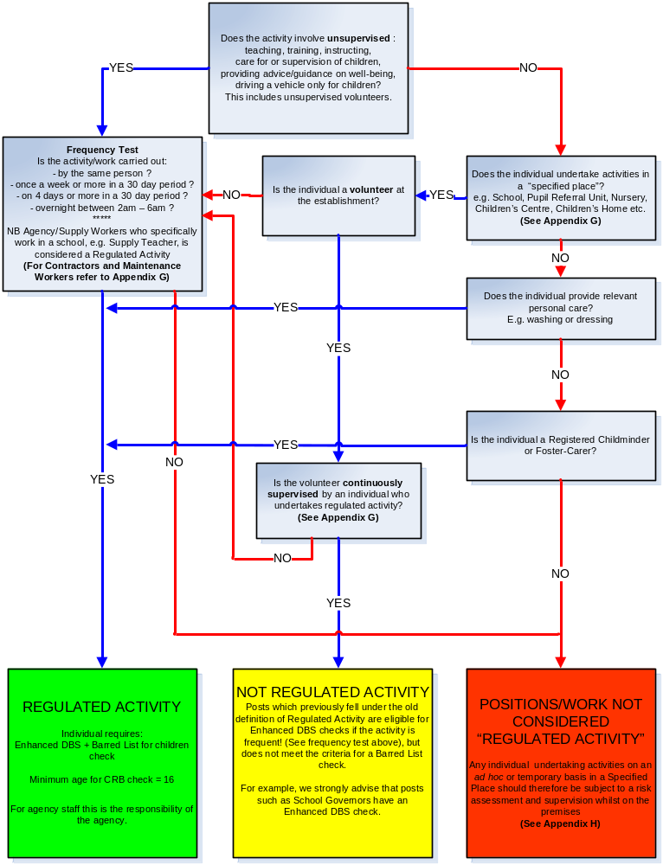

Appendix D: Flowchart to Asses Regulated Activity For Adults
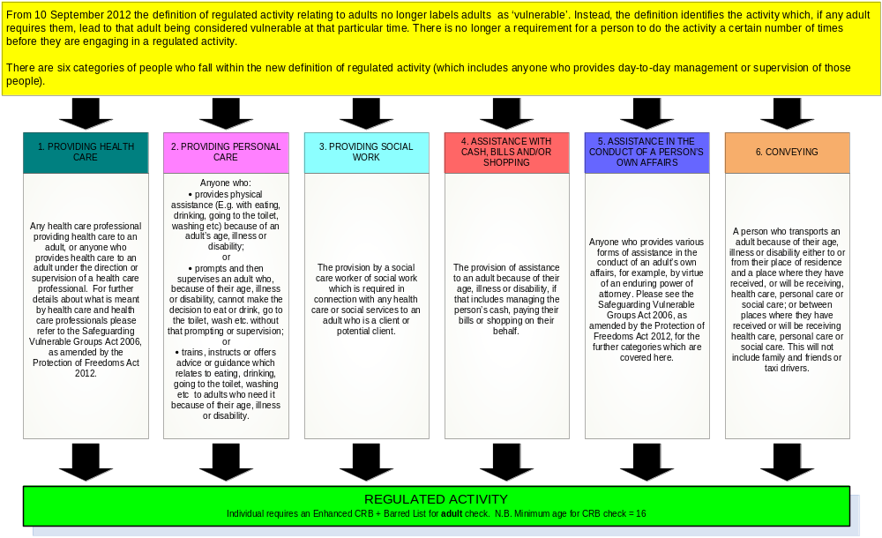

Appendix E: Safe Handling and Storage of Disclosure Information

Information about offences must be kept confidentially on a need-to-know basis in lockable filing cabinets and/or on a secure electronic system. Access must be restricted to individuals responsible for recruitment and relevant HR staff.

Positive Disclosures must normally be destroyed within six months of the recruitment decision and not later than the period specified in the ‘Code of Practice for Registered Persons and other recipients of Disclosure Information’.

The name of the individual, the date, type and reference number of the Disclosure and the position applied for can be kept as a record of the recruitment decision taken but must be kept confidential.

Appendix F: Rehabilitation of and Employment of Ex Offenders

(A copy of this policy must be made available to all applicants for jobs requiring a disclosure.)

1. Introduction

Applicants for certain posts are are subject to a criminal record and barred list checks in accordance with legislation relating the rehabilitation of offenders. This will include details of cautions, reprimands, warnings and convictions in accordance with the DBS filtering rules (see appendix G).

2. Use of Criminal Record/Convictions Information

The disclosure of criminal record and barred list information will be used as one tool within the recruitment process. Applicants must be informed at the outset if this information will be requested from them, which will provide a basis for them to decide whether or not to apply for the post. It should be emphasised that this information will be used only to assess the applicant’s suitability for employment..

Applicants must be told in writing that relevant criminal convictions and other associated information will be discussed at interview to assess job-related risks. They should be encouraged to submit appropriate written details and dates to a named and invited to attach any other information they wish to draw attention to that may improve understanding and fair decision-making.

When recruiting to posts exempted under the Rehabilitation of Offenders Act, the level of DBS check must be specified. When recruiting to posts not exempted under the Rehabilitation of Offenders Act, unspent criminal convictions should be taken into account only when they are relevant to the post.

At the interview, issues concerning offences must be raised with applicants as part of a carefully structured and managed process that allows open and honest discussion. They must also be given the opportunity to discuss disclosure information before a final recruitment decision is made as part of a post-interview process.

If information provided in the disclosure contradicts that provided by the applicant, this will be discussed with the applicant in person as part of a post-interview process. They must be given the opportunity to explain the situation before a final decision is made.

Where disclosure information is sought in relation to existing employees and it is then discovered they have failed to disclose an ‘unspent’ conviction, they should not necessarily be dismissed. Only after a full appraisal of the situation (see 3 below) including the risks involved, should dismissal be considered. The relevance of the conviction to the post should be established. If an employee deliberately withheld conviction information to gain employment , disciplinary action must be considered.

3. Assessing the relevance of criminal records

The suitability for employment of a person with a criminal record will vary depending on the job and the details and circumstances of any convictions. An assessment of their skills, experience and conviction circumstances should be weighed against the risk assessment criteria for the job.

An applicant’s criminal record will be assessed in relation to the tasks he or
she will be required to perform and the circumstances in which the work is to
be carried out. The following will be considered when deciding on the relevance of offences to particular posts.

- Does the post involve one-to-one contact with children or other vulnerable groups as employees, customers and/or clients or does it involve management of such posts?
- What level of supervision will the post holder receive?
- Does the post involve any direct responsibility for finance or items of value?
- Does the post involve direct contact with the public?
- Will the nature of the job present any opportunities for the post holder to re-offend in the place of work?

The answers to such questions will help the Council to determine the relevance of convictions to specific posts. For short-listed applicants who are assessed as meeting the requirements of the person specification who then disclose a criminal record that is not related directly to the post, the recruiting manager should discuss the relevance of each offence with the applicant. Whilst it will not always be possible to carry out a thorough risk assessment on each individual, the following issues should be taken into account as a minimum requirement.

- The seriousness of the offence and its relevance to the safety of other employees, customers, clients and property.
- The length of time since the offence occurred
- Any relevant information offered by the applicant about the circumstances which led to the offence being committed, for example the influence of domestic problems, financial difficulties, drug/alcohol dependency or mental illness.
- Whether the offence was a one-off, or part of a history of offending
- Whether the applicant’s circumstances have changed since the offence was committed, making re-offending less likely.
- The country in which the offence was committed; some activities are offences in Scotland and not in England and Wales, and vice versa
- Whether the offence has since been decriminalised by Parliament.
- The degree of remorse, or otherwise, expressed by the applicant and their motivation to change.
4. Reviewing policies and procedures

Criminal record information must be used in a way that protects the vulnerable, is fair and improves the overall recruitment and retention process. In particular, the Council will:
- Review new posts to assess whether they involve any risk.
- Ensure staff involved in recruitment are provided with guidance on the employment of ex-offenders and the Rehabilitation of Offenders Act.
- Provide information to staff involved in recruitment, on training and employment programmes for the unemployed, including those programmes that work specifically with ex-offenders.
- Provide relevant feedback related to their convictions to all unsuccessful applicants.

Appendix G: Definitions and Additional Information

Building and Maintenance Contractors working in a ‘specified place’, eg a school | - This no longer meets the new definition of ‘regulated activity’. However, an assessment should be undertaken to assess any potential risks so that appropriate measures can be put in place whilst contractors are on site; and it may be appropriate to undertake a DBS check under the old definition of regulated activity.
Conveying | - A person who transports an adult because of their age, illness or disability either to or from their place of residence and a place where they have received, or will be receiving, health care, personal care or social care; or between places where they have received or will be receiving health care, personal care or social care. This will not include family and friends or taxi drivers.
DBS Update Service | - The Disclosure and Barring Service (DBS) update service lets applicants keep their DBS certificates up to date online and allows employers to check a certificate online. There is a fee payble for this service by the individual.  - Employers and other organisations can check someone’s DBS certificate status online and get a result straight away. There’s no registration process or fee for employers to check a certificate online, but employers: must be legally entitled to carry out a check; and have the worker’s permission
Filtering Rules | From 29 May 2013, amendments to the Exceptions Order 1975 (2013) provide that certain spent convictions and cautions are 'protected' and are not subject to disclosure to employers , and cannot be taken into account. This means in summary:  For those 18 or over at the time of the offence  An adult conviction will be removed from a DBS Certificate if: 11 years have elapsed since the date of conviction; and it is the person’s only offence; and it did not result in a custodial sentence.  Even then, it will only be removed if it does not appear on the range of offences which will never be removed from a certificate, which include serious sexual and violent offences. (see Exceptions to the Rules). If a person has more than one offence, then details of all their convictions will always be included.  An adult caution will be removed after six years have elapsed since the date of the caution – and if it does not appear on the list of offences relevant to safeguarding.  For those under 18 at the time of the offence  For convictions, the same rules apply as for adult convictions, except that the elapsed time period is five and a half years.  For cautions, the same rules apply as for adult cautions, except that the elapsed time period is two years.  Exceptions to the Rules  Some offences will never be removed from a DBS Certificate. These include the most serious sexual and violent offences.
Frequency Test (this only applies to Regulated Activity for Children but not those who provide personal care, foster carer or registered childminders. | - Work carried out at the same “specified place” (see definition below) by the same person once a week or more often, or for 4 or more days in a 30 day period; or intensely, ie overnight between 2am and 6am.
Regulated activity – children: | - Unsupervised activities: teach, train, instruct, care for or supervise children, or provide advice or guidance on well-being, or drive a vehicle only for children;  - Work for a limited range of establishments (‘specified place’ ), with opportunity for contact, eg school, PRU, nursery, children centre, children’s home etc, BUT not work by supervised volunteers.  Work undertaken under these two points is regulated activity only if done frequently – see definition for ‘Frequency Test’.  - Relevant personal care, for example washing or dressing; or health care by or supervised by a professional.  - Registered childminding and foster-carers  Work undertaken by these two points are not subject to the frequency test.
Regulated activity – adults: | - The new definition no longer relates to adults as ‘vulnerable’ but instead defines the activities which if any adult requires them, lead to that adult being considered vulnerable at that particular time. This means the focus is on the activities required by the adult; not on the setting in which the activity is received, nor on the personal characteristics or circumstances of adult receiving the activities.  - Activities include: providing health care; personal care; social work; assistance with cash, bills and/or shopping; assistance in the conduct of a person’s own affairs; and conveying. See Appendix X.  - There is no longer a requirement for a person to do the activities a certain number of times before they are engaged in regulated activity.
‘Specified Place’ within the definition of Regulated Activity for Children is: | - Schools (including Academies) (all or mainly full time, for children)  - Pupil referral units (also known as Short Stay Schools) not falling within the above  - Nursery schools  - Institutions for the detention of children  - Children’s homes  - Children’s centres in England;  - Childcare premises (including nurseries)  Note: Any other settings that are not included in the above list (such as youth centres and libraries) are not considered as a ‘specified place’ but individuals undertaking certain activities, may still meet the definition of regulated activity.
A volunteer as defined by DBS: | - A person who is engaged in any activity which involves spending time, unpaid (except for travelling and other approved out of pocket expenses), doing something which aims to benefit someone (individuals or groups) other than, or in addition, to close relatives.

Appendix H: Risk Assessment
For post-holders starting employment/work (including volunteers) prior to completion of DBS check

Post-holders Name: |  | Date:
Job Title: |  | Division/Dept:

Type of work/employment | Permanent: ◻ Temporary/FTC: ◻ | If temporary/FTC state anticipated end date:
Have all pre-employment checks been completed and verified to a satisfactory level?  Note: Volunteers do not require the same level of checks as an employee but (as a minimum) at least one reference should be sought and verified. | Reference (1): Yes / No  Qualifications: Yes / No  Right to work in the UK: Yes / No | Reference (2): Yes / No  Health check: Yes / No
Has a DBS check been requested: | Yes / No  If yes, state when the application was made:  If the candidate has worked or lived abroad in the last 5 years has an additional criminal record check been requested/carried out – please provide details:
Will the post holder have direct access to children and/or vulnerable adults?

Will the post holder be supervised by a person who has the relevant DBS check? | Yes / No  What level of DBS check has been carried out on the supervisor?
Will supervision be regular and day to day? | Please provide details:

It is important to ensure that supervision is reasonable, and the level of supervision may differ depending on the circumstances/needs of the vulnerable group. The manager/head teacher should therefore consider the following factors in deciding the specific level of supervision that is required in an individual case.

Factors to consider  (note, where an * is indicated, delete as appropriate) | Provide details | Is this a possible risk?  If no, state why not  If yes, state the safeguarding measures  you will be putting in place
- Ages of the children/vulnerable adults*, including whether their ages differ widely
- Number of children/vulnerable adults* that the individual is working with
- Whether or not other workers are helping to look after the children/vulnerable adult*
- The nature of the individual’s work or, in a specified place such as a school, the individual’s opportunity for contact with children/vulnerable adults*
- How vulnerable the children/adults* are, in relation to their needs
- How many workers would be supervised by each supervisor

Name of Manager: |  | Date:

including Croydon maintained schools
Taken from the Ofsted guidance to schools (Inspecting Safeguarding, Sept 2012, pg 11).
This is only an indication of the DBS level that may apply. Managers are still required to assess the level of check for each post
Reference numbers taken from DBS eligibility guide (September 2013)

