**Preparing for the Spring 2020 Pupil Census**

**Our SIMS support team give you top tips on how to prepare for the Spring 2020 Pupil Census and what you need to do on the day:**

**What is the Pupil Census and who does it apply to?**

The **School Census** is a statutory data collection for all maintained (state-funded) schools in England. This includes nursery, primary, secondary, middle-deemed primary, middle-deemed secondary, local authority maintained special and non-maintained special schools, academies including free schools, studio schools and university technical colleges and city technology colleges. There are three termly collections: spring, summer and autumn.

**Preparation:**

It is important to prepare yourself for the Spring Pupil Census. You should do a dry run as far in advance as possible. This will allow time to resolve any queries or errors that may appear.

Reading the guidance that is available is essential to your preparation. The guidance provided by the DfE can be found [here](https://assets.publishing.service.gov.uk/government/uploads/system/uploads/attachment_data/file/848327/2019-20_School_Census_Business_and_Technical_Specification_V1.6.pdf) and the Capita SIMS [here](http://simspublications.com/754218/assets/censusprepprnusp.pdf).

The DfE information is the complete reference document for the Pupil Census. The guide usually answers most frequently asked questions. If you have any doubts about the information you are returning, then contact your Management Information System (MIS) provider or support team or your local authority.

Capita and RM both have extensive Pupil Census preparation guides.

**File set Required?**

***File set ID 1400 or higher***

If you use SIMS, then you will need to make sure you have the latest version of the Census File set. For schools that use SIMS, the latest File set is updated automatically via SOLUS 3. Schools using other MIS systems, will need to seek advice from their provider to ensure they have the latest census File set. The File set ensures that your SIMS or MIS system will output the return in the latest required format according to the DfE specification. You may wish to contact your SIMS support team to check whether you have the right version.

**What Version of SIMS is Required?**

To run this return, you must have the SIMS 2019 Autumn Release (7.190) or later installed.

To check which version of SIMS is installed, open SIMS and then select **Help | About SIMS**. A dialog like the one shown in the following graphic should be displayed. The version should read 7.190 or later. For other MIS system, please check with your MIS support provider.



**Key Dates and Timeframe**

Key Dates Primary, Nursery, PRU and Special

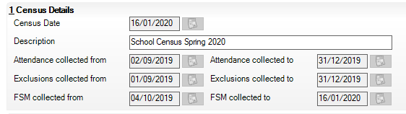

Key Dates Secondary

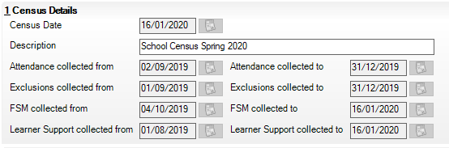

The Census Date for the Spring 2020 Census is 16th January 2020. This date will be the reference date, to which all required data (pupils and school) is collected.

The DfE gives a two- week grace period after this date, by which all schools should submit their Spring 2020 census return file. The LA may give a shorter time for Maintained schools. Please look at the latest school bulletin for any information relation to the Spring 2020 pupil census.

**Final Thoughts**

It is important to check all the detailed and summary reports that your MIS system produces.

When checking the detailed and summary reports, be aware of the date ranges that are stipulated and criteria of the report. There may be differences in pupil numbers depending on what is required of the data.

If in doubt, ask! There is no such thing as a silly question. If the DfE, Capita or RM guidance is not making sense then please do call your MIS team, LA contact or as a last resort, the DfE through the Secure access portal.

**Our top tip: Prepare in advance.**