To keep children’s lunches as healthy as possible, we would like the following items not to be included in packed lunches:
What should a packed lunch not include?
- Crisps or bagged crisp type products
- Sweets
- Chocolate or chocolate items such as biscuits, yogurts, cakes or desserts
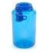
What drinks should be included?

*** school is a water only school with the exception of free school milk.
Fresh drinking water is provided for all packed lunch children therefore parents/carers do not need to include a drink in lunchboxes.

How will packed lunches be monitored?
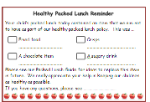
To ensure that children eat a healthy balanced meal, Lunchtime Supervisors will monitor packed lunches. If a packed lunch has an item that we discourage, a reminder slip will be sent home.
Children with healthy packed lunches and those who make healthy school meal choices may appear on our ‘Lunchtime Stars’ board.
For more information about packed lunches, please speak to ***
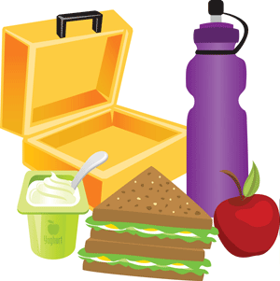
Packed Lunch Guide
For families at *** Primary School
2022 - 2023

2. Include some dairy
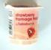 | 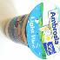 | 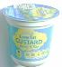
Fruit yoghurt | Rice pudding | Custard | Cheese portion | Yoghurt tube
Why eat a healthy packed lunch?
New School Food Standards were introduced in January 2015 to ensure that all pupils are getting balanced and healthy food in school.
3. Include some fruit or vegetables
 | 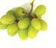 | 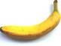 | 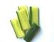
Satsuma | Grapes | Banana | Cucumber | Carrot batons
 |  | 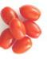 | 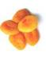
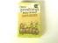 | 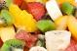 |  |  | 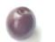
Raisins | Tinned fruit salad | Cherry tomatoes | Dried apricots | Plum
We have used these standards to create our packed lunch guide and help families with ideas. A healthy packed lunch can help children to:
- Have enough energy to concentrate and learn in the afternoon.
- Keep calm and be prepared to do their best.
- Get important nutrients to keep their bodies healthy.
What should a packed lunch include?

Use the following ideas to help plan a healthy lunch for your child.
1. Include a savoury main (with some salad)
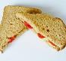 | 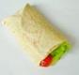 | 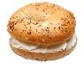 | 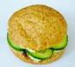 | 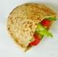
Cheese & tomato sandwich | Tuna and salad wrap | Cream cheese and lettuce bagel | Hummus and cucumber roll | Chicken salad pitta bread
 | 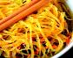 | 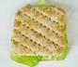 | 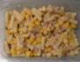 | 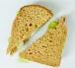
Carrot and chickpea cous cous | Chicken and pepper noodles | Sardine and lettuce thin | Tuna and sweetcorn pasta | Egg, pepper and lettuce sandwich
4. Include an extra low fat/low sugar snack, if needed (older pupils)
 | 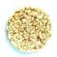 |  |  | 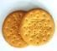
Plain breadsticks | Plain rice cakes | Small fruit scone | Crackers | Plain biscuit

We ask families to include an ice-pack in each packed lunch to keep the food cool OR we provide a fridge to keep packed lunches in during the school day.

